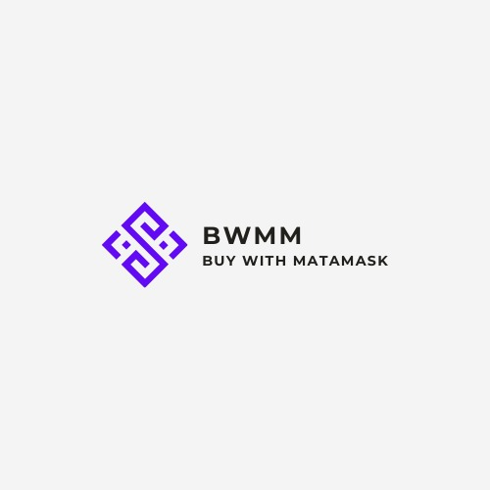

**Project Team:**

* Obaidullah Ishtiaq SP20-BSE-042 ***(Leader)***
* Muhammad Abdullah SP20-BSE-074 ***(Front-End)***
* Muhammad Haris Amer SP20-BSE-045 ***(Back-End)***
* Muhammad Asad Akmal SP20-BSE-029 ***(Back-End)***

**ABSTRACT:**

As we know that Today’s world is going toward digitalization in every aspect of life. Easy, timesaving, efficient and hustle-free online payment in online shopping is the main concern for the customer. But this environment is very difficult to find in ecommerce store now day in Pakistan. As officially, PayPal does not work in Pakistan and when we pay through our banking system every time, they want to have our personal information, these systems are slow too because they do different type of verification. And sometimes we are unable to use bank services due to centralize architecture.

The primary objective is to give customer to pay using crypto currency Ethereum and with other banking account as well. So that customer can easily pay with his/her crypto wallet

**Introduction To the Project:**

Our project is **BWMM**, **BWMM** is an ecommerce store web base application, architecture of **BWMM** is D2C means where retailer can sell their products to customers. Aim of project is to provide customers a secure payments procedure through crypto wallets (Meta mask) as well as encrypted bank payments (Stripe, Mastercard’s etc.)

**Product Features:**

Following are the features of our project

* Payment through cryptocurrency.
* Payment through Stripe
* A cart functionality to store product that a customer is going to buy
* Encrypted authentications for customers
* For guest users their cart history will be stored in their browsers

**Tools:**

Following are the tools that we are using for designing and development

* Html CSS and JavaScript , bootstrap will be used for the front-end development.
* A framework of python (Django) will be used for backend Development.
* Data base will be SQLite.

**Tools For Quality assurance**

We are going to do testing in every phase of development life cycle

* Python library (PyTest).
* Django’s test for testing.

**Tools for version controlling**

* **Git :**

Online Repository: <https://github.com/ObaidOIS/BuyWithMataMask>

**Timeline:**

As we are doing development according to Semester Calendar of SPRING2022

* 6th -8th Week Project Scope and Requirement Specification
* 9th – 10th Week Project Documentation
* 11th – 14th Week Project Implementation
* 15th – 17th Week Testing
* 18th Week Final submission

**Gantt Chart:**

